

**A Project Topic**

**On**

**“Helicopter War”**

“Bank Account Management System”

**Submitted by:**

**MD Imran Hosen (18CSE019)**

**Date: November 2020**

**Department of Computer Science & Engineering**

**Bangabandhu Sheikh Mujibur Rahman Science and Technology University**

Helicopter war

(This project is submitted in the partial fulfillment of the requirement for the project of "Third Year Second Semester" in Computer Science & Engineering)

By

**MD. Imran Hosen**

**ID: 18CSE019**

Supervised by

**Md. Nesarul Hoque**

Assistant Professor

Department of Computer Science & Engineering

Bangabandhu Sheikh Mujibur Rahman Science and Technology University

# CERTIFICATE OF APPROVAL

It is hereby declared that the contents of this project is original and any part it has not been submitted elsewhere for the award of any degree or diploma.

---------------------------------- ---------------------------------

Signature of the Candidate Signature of the Supervisor

Date: Date:

# ACKNOWLEDGEMENT

The success and final outcome of this project required a lot of guidance and assistance from many people and I am extremely privileged to have got this all along the completion of my project. All that I have done is only due to such supervision and assistance and I would not forget to thank them. I owe my deep gratitude to our project supervisor Md. Nesarul Hoque, who took keen interest on our project work and guided us all along, till the completion of our project work by providing all the necessary information for developing a good system. I am thankful to and fortunate enough to get constant encouragement, support and guidance from all Teaching staffs of Computer Science and Engineering which helped me in successfully completing my project work.

Md. Imran Hosen

November, 2020

# ABSTRACT

The Helicopter Game in C++ is an interesting game/console application designed in the object oriented programming language – C++, with the use of Visual Studio 2013. The game is an excellent example of utilization of C++ programming language in the field of game development. It demonstrates all the basic commands, syntaxes, functions, structures as well as concepts of file handling in C++.

The rules and regulation of the game are very basic and easy to understand. The game scenario puts the player in control of a hovering dot in the screen with moving obstacles of pipelines. The goal of the game is to get through the opening in the obstacles without colliding into them. The game is implemented in C++. The case study discusses the use of simpler motion and modification to build the abstraction.

In addition, this report will also discusses the strategies used to stimulate the crowd pattern in the leisure environment. The game is in single and multiplayer player mode.

The user can interact with the game using keyboard. The position of the obstacles will also be discussed. The game is a 2D game with the purpose to keep the dot moving forward.

# TABLE OF CONTENTS

|  |  |  |
| --- | --- | --- |
| Chapter 1 | Introduction and Overview | 8 |
| 1.1 | Features | 8 |
| 1.2 | Objectives | 9 |
| 1.3 | System Suggested | 9 |
|  |  |  |
| Chapter 2 | **System Study** | 10 |
| 2.1 | The Player Helicopter | 10 |
| 2.2 | The Enemy Helicopter | 10 |
| 2.3 | The Enemy Tank | 11 |
| 2.4 | The Enemy Ship | 11 |
| 2.5 | Player 1 Helicopter | 11 |
| 2.6 | Player 2 Helicopter | 12 |
| 2.7 | Collision Detection | 12 |
|  |  |  |
| Chapter 3 | **Design Specification** | 13 |
| 3.1 | Input and Output Design | 13 |
| 3.1.1 | Single Play Option | 14 |
| 3.1.2 | Multiple Play Option | 14 |
| 3.1.3 | Instruction Option | 15 |
| 3.1.4 | Quit Option | 15 |
| 3.1.5 | Other Option | 15 |
| 3.2 | Game Level Design | 15 |
| 3.2.1 | First Level | 16 |
| 3.2.2 | Second Level | 16 |
| 3.2.3 | Game Over Option | 17 |
| 3.3 | Audio generator | 17 |
|  |  |  |
| Chapter 4 | **Results** | ­18 |
|  |  |  |
| Chapter 5 | **Conclusion and Future Scope** | 20 |

**List of Figure**

|  |  |  |
| --- | --- | --- |
| Figure-2.1 | Player Helicopter | 10 |
| Figure-2.2 | Enemy Helicopter | 10 |
| Figure-2.3 | Enemy Tank | 11 |
| Figure-2.4 | Enemy Ship | 11 |
| Figure-2.5 | Player 1 Helicopter | 12 |
| Figure-2.6 | Player 2 Helicopter | 12 |
| Figure-3.1 | Main Menu | 13 |
| Figure-3.2 | First Level | 14 |
| Figure-3.3 | Second Level | 14 |
| Figure-3.4 | Multiple Play | 15 |
| Figure-3.5 | Instruction | 15 |
| Figure-3.6 | Quit Option | 16 |
| Figure-3.7 | Level One | 16 |
| Figure-3.8 | Level Two | 16 |
| Figure-3.9 | Game Over | 16 |
| Figure-4.1 | Point and Health | 19 |
| Figure-4.2 | Player One Win | 19 |
| Figure-4.3 | Player Two Win | 19 |

# CHAPTER ONE

# INTRODUCTION AND OVERVIEW

Now we are living in the ocean of science and technology. This is possible for the purposes of programing. The main purpose of this project is to introduce programing everyone and practice them. In this, project design and implement a Helicopter Game like video game on the Visual Studio development board. In this game, the player can control the vertical movement of bird (Every pressing on the keyboard makes the bird leap upward for a little bit, and the bird will fall freely without control ). As soon as the game begins, tubes will keep appearing from the right side of the screen and moving leftwards (so that it seems like the bird flying forward). The goal of this game is to control the bird, going and passing the incoming tubes, as many as possible. The game is endless until the bird eventually hit one of the tubes, ground, or ceiling.

The following is an example game written in C++ based on the game called ‘Helicopter game’ which has been around since he earliest days of home computing and has re-emerged in recent years on mobile phones.

It is not the world’s greatest game, but it does give you an idea of what you can achieve with a relatively simple C++ program, and perhaps the basic by which to extent the principles and create more interesting games.

## **Features**

* GUI Interface
* Single and Multiplayer game
* Keyboard interaction
* Use I-Graphics

## **1.2 Objectives**

I made this game or project so that I could give our best in possible ways and show what I learned. The objectives of this project are:

* To play the famous game flappy bird in computer.
* To make it user friendly.
* To provide an easy interface.
* To entertain people in their leisure time.

## **System Suggested**

* Operating System : Windows XP or more
* Software : Visual Studio 2013

# **CHAPTER TWO**

# **SYSTEM STUDY**

For the game to feellike real helicopter game, the focus is given on the game play. The three essential elements that the game needs to get right are the player helicopter and the enemy helicopter also the enemy tank. Specifically, the helicopter has to move around. This all picture I download form google and work on adobe photoshops PS6.

## **2.1 The Player Helicopter**

The player helicopter can move by keyboard and also fire enemy helicopter and tank. For move player helicopter we have 4 button Up, Down, Right, Left. And for fire enemy we have 6 button. For enemy helicopter destroy we have boom for lunch those boom we have to press 1, 2, 3 button.



**Figure 2.1 - Player Helicopter**

## **2.2 The Enemy Helicopter**

The enemy helicopter come right to left but enemy helicopter does not fire. Enemy helicopter cross right to left completely then player lose health .Also we can destroy enemy helicopter by 1, 2, 3 button.



**Figure 2.2 -Enemy Helicopter**

## **2.3 The Enemy Tank**

There are 2 enemy tank comes right to left but enemy tank does not fire. Enemy tank cross right to left completely then player lose health .Also we can destroy enemy tank by 4, 5, 6 button.

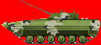

**Figure 2.3-Enemy Tank**

## **2.4 The Enemy Ship**

There are 2 enemy ship comes right to left but enemy tank does not fire. Enemy tank cross right to left completely then player lose health .Also we can destroy enemy ship by 4, 5, 6 button.

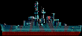

**Figure 2. 4- Enemy Ship**

## **2.5 Player 1 Helicopter**

After tap multiple play than we can show two player .we can control 1st player by keyboard button.

W -up

S –down

A –left

D –right

Q, E, F –shoot



**Figure 2.5- Player 1 Helicopter**

## **2.6 Player 2 Helicopter**

After tap multiple play than we can show two player .we can control 1st player by keyboard button.

I -up

K –down

J –left

L –right

U, O, P –shoot



Figure 2. 6-Player 2 Helicopter

## **2.7 Collision Detection**

When should the game over? When enemy and player helicopter head-on collision together then game will be over also player missed to destroy enemy helicopter and tank then our health going down. When our health going down to zero than game will be over.

# **CHAPTER THREE**

# **DESIGN SPECIFICATION**

Game design is a knowledge area that includes game genres, game production, marketing, publishing, and project management. Game design is the common core where game art and game programming take off from to create the game.

Game Design involves market research, level design, designing content, environment, gameplay, characters, and the storyline of a game. As a game designer, you must know the aesthetics of design and its interaction with technology well. I discuss about my design of my Helicopter Game. The first look in my game.

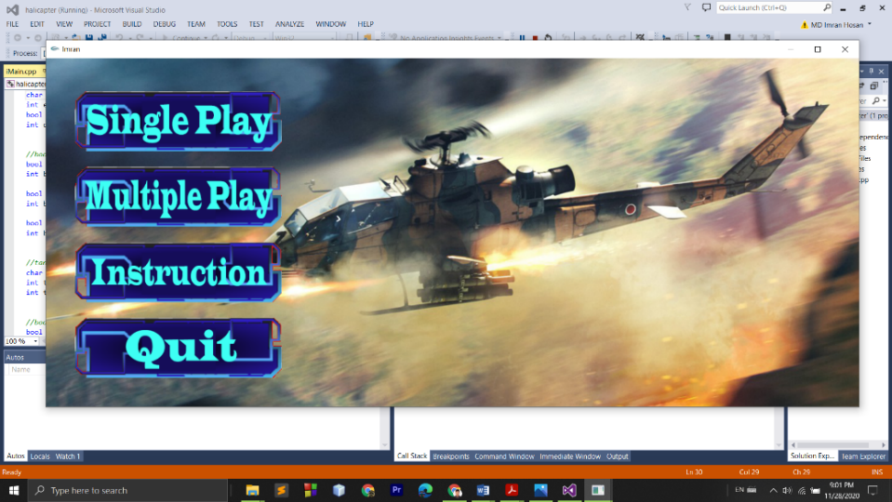

**Figure 3.1-Main Menu**

## **3.1 Input and Output Design**

* Single Play Option
* Multiple Play Option
* Instruction Option
* Quit Option

### **3.1.1 Single Play Option**

After tap single button, my game will be start. Single play option only one player can play. In first , game will be easy but after achieve more point game will to hard for play.

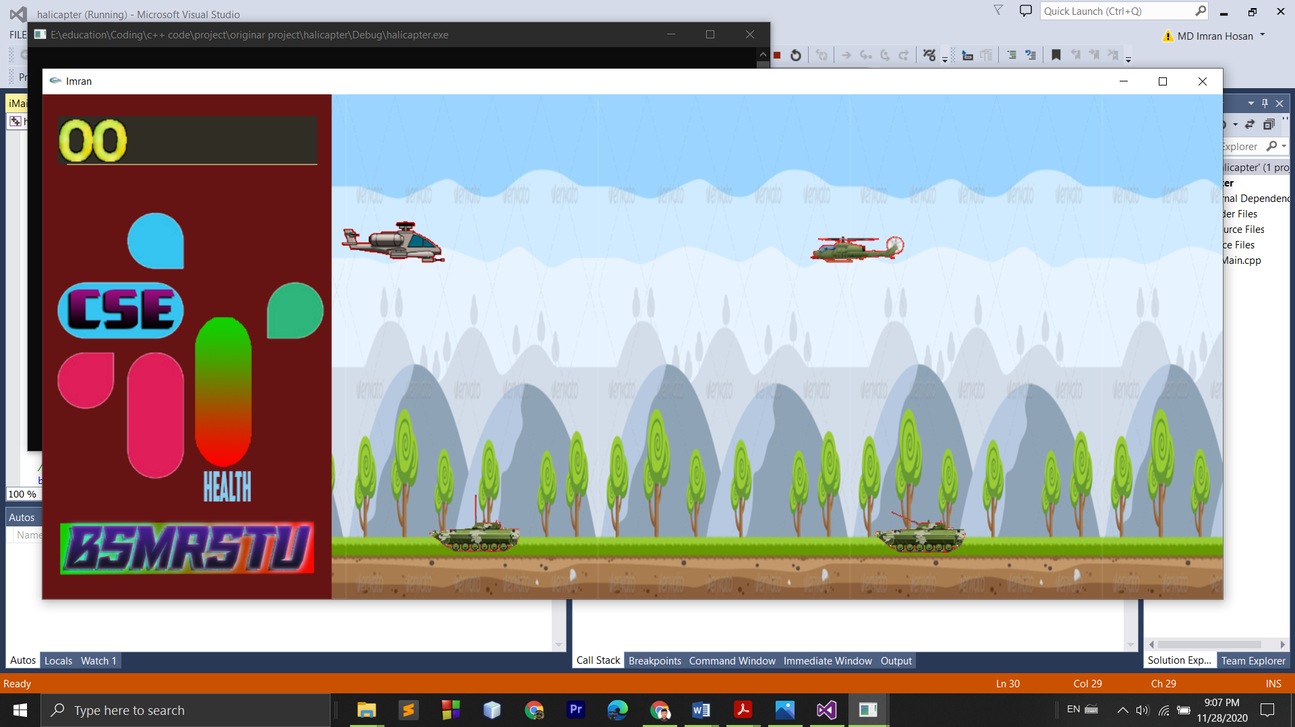

**Figure 3.2-First Level**

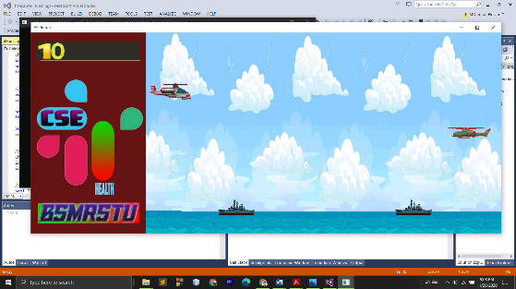

**Figure 3.3-Second Level**

### **3.1.2 Multiple Play Option**

After tap multiple button.

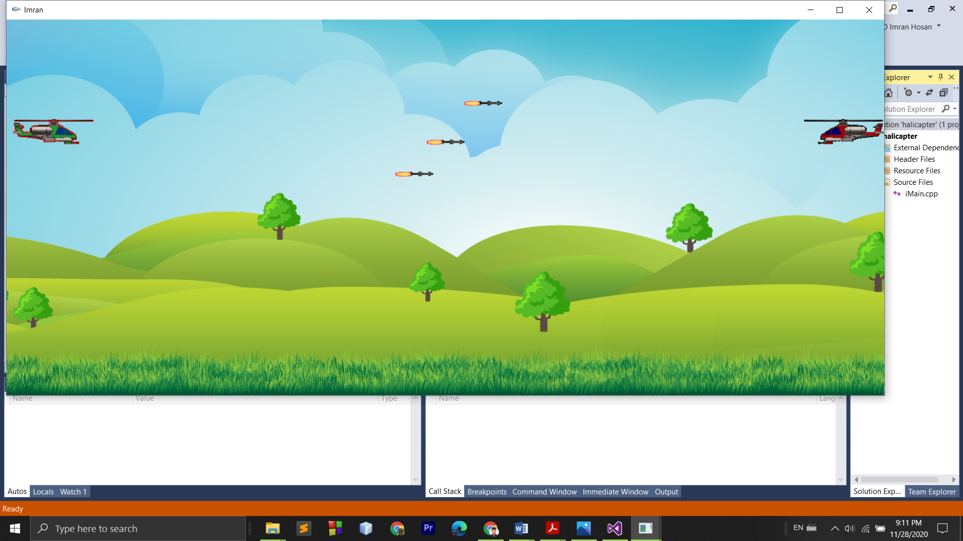

**Figure 3.4-Multiple play**

### **3.1.3 Instruction Option**

After tap Instruction button.

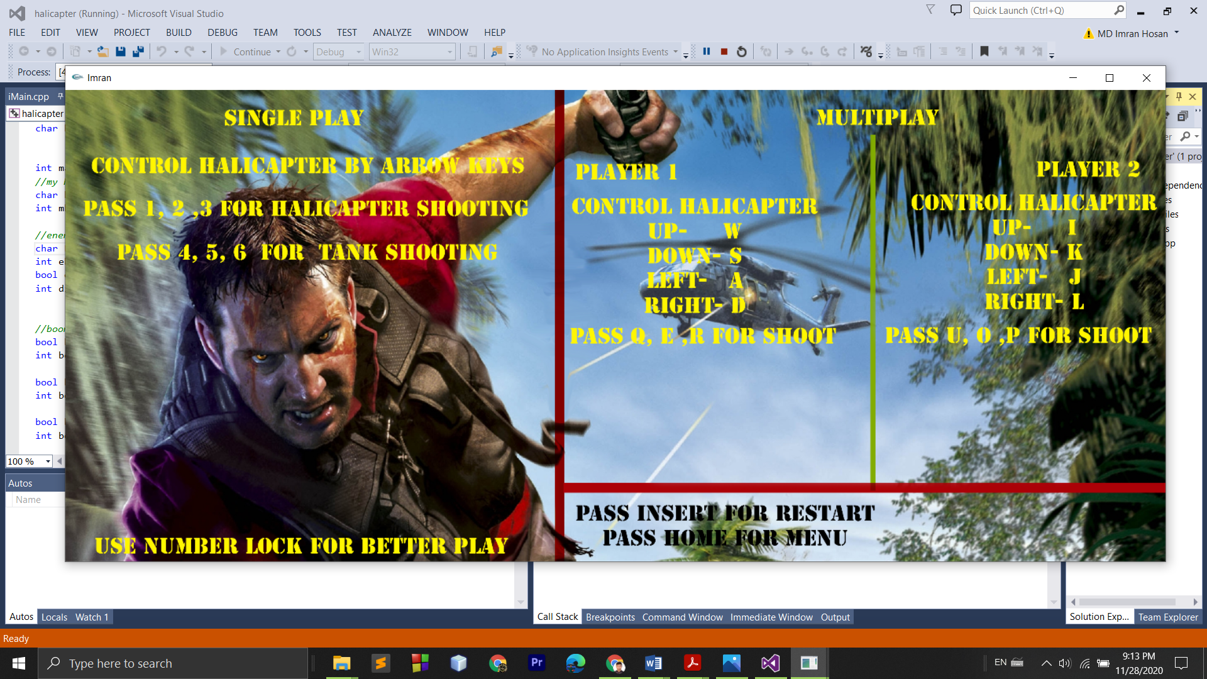

**Figure 3.5-Instruction**

### **3.1.4 Quit Option**

After tap quit button.

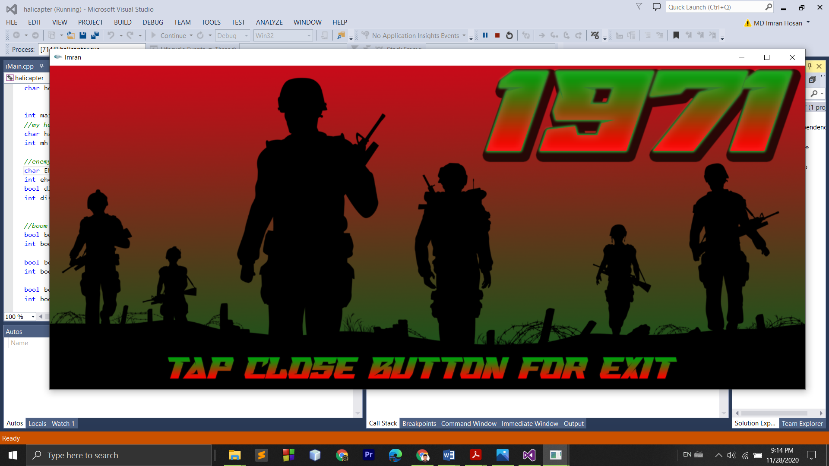

**Figure 3.6-Quit Option**

### **3.1.5 Other Option**

When player play single play option than after game over, we have 2 option

Press Insert – For Restart

Press Home – For Menu

When player play multiple play option than after game over, we have 1 option

Press Home – For Menu

## **3.2 Game Level Design**

There have two level in my game. In first level player have to play in land after achieve some point then player automatically transfer to sea second level and second level player play in sea.

### **3.2.1 First Level**

My First level player play in land. There are three component we can show one enemy helicopter and two enemy tank. There are simple rules of first level .We have to destroy enemy tank and ship. Otherwise our health will be go down and after achieve 3000 point player can play second level of this game.



**Figure 3.7-Level one**

### **3.2.2 Second Level**

Second level player play in sea. In second level enemy helicopter will be same but enemy tank will transfer to ship. But system is same in second level enemy ship speed will be increase.

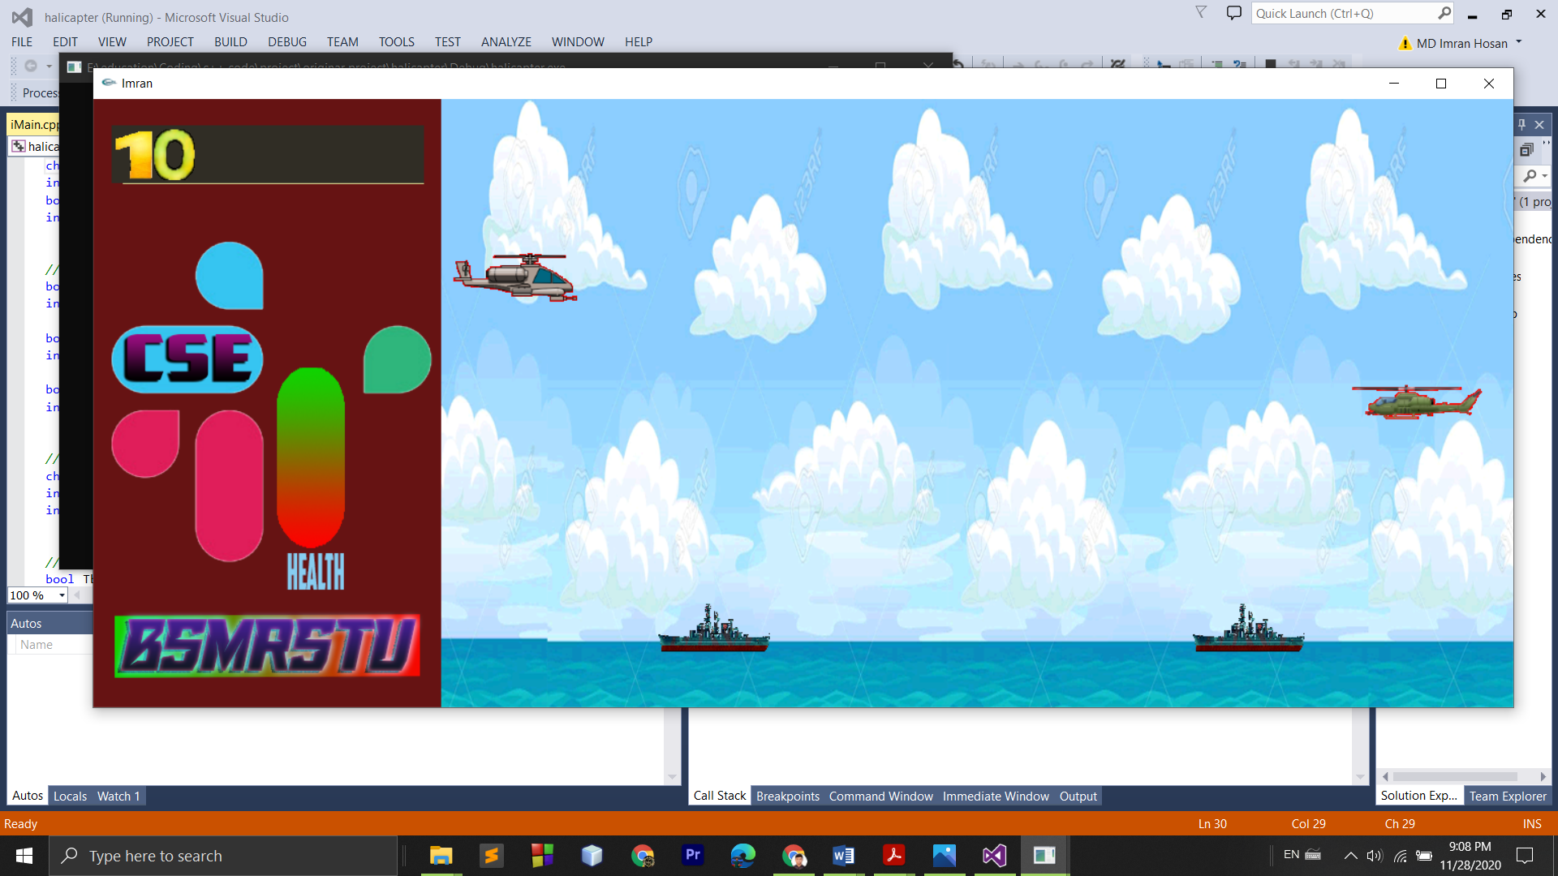

**Figure 3.8-Level Two**

### **3.2.3 Game Over Option**

When our health down to zero or enemy and player helicopter head-on collision together. Then game will be over.

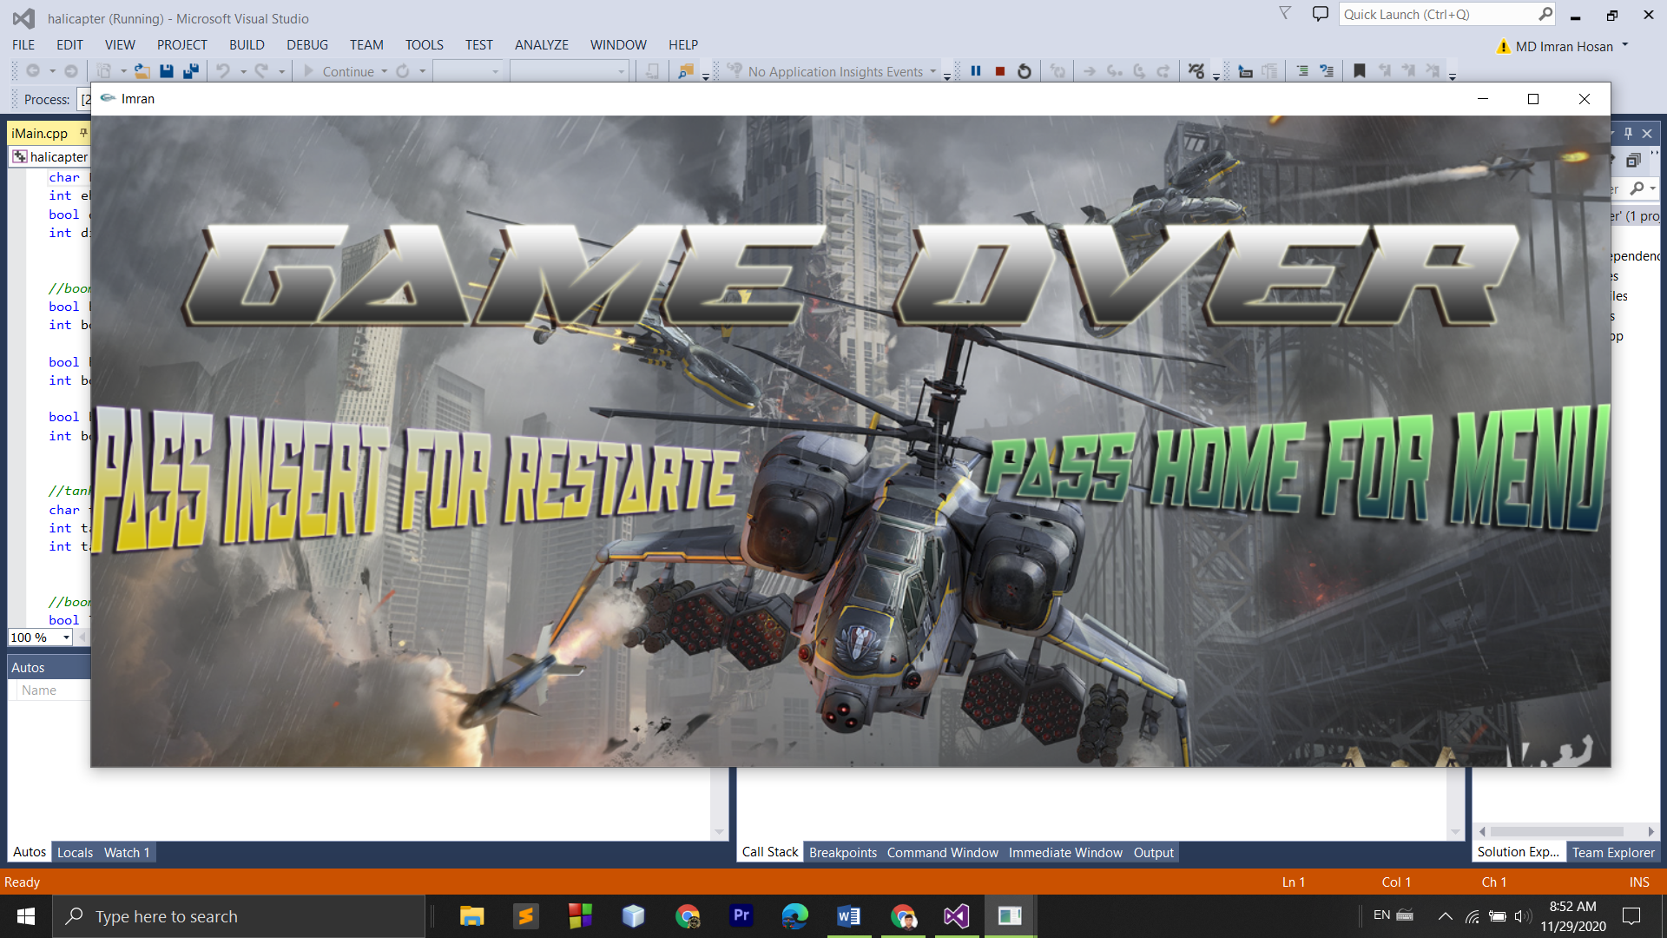

**Figure 3.9-Game Over**

## **3.3 Audio generator**

There are two audios to be played, one played once pressing the Main menu and Game over screen , and two played consecutively once the game is playing in single and multiple mode. The selection of the audio is based on the signals from "Game Rule" submodule.

# **CHAPTER FOUR**

# **RESULTS**

The Helicopter has two option single and multiple play. When player play single option then player can see his point in left upper side. Also player can see his health in left side. If player destroy one helicopter or ship then player will get 10 point and player miss any of them player life will be down , after miss 13 ship or helicopter game will be over. Also if player get 3000 point he can play second level.



**Figure 4.1-Point and Health**

Multiplayer option when player 1 win.

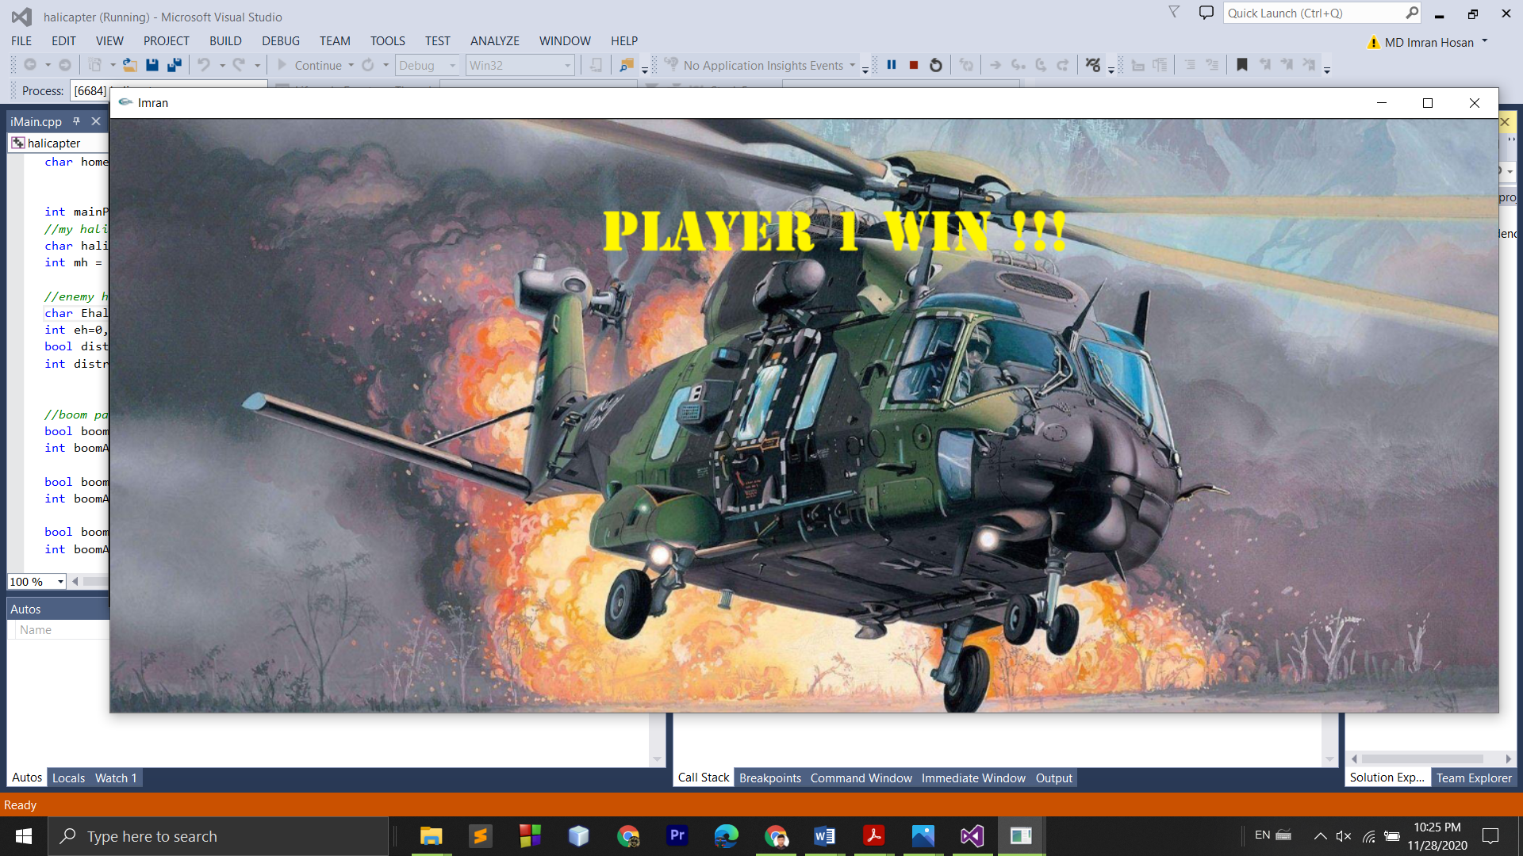

**Figure 4.2-Player One Win**

Multiplayer option when player 2 win.

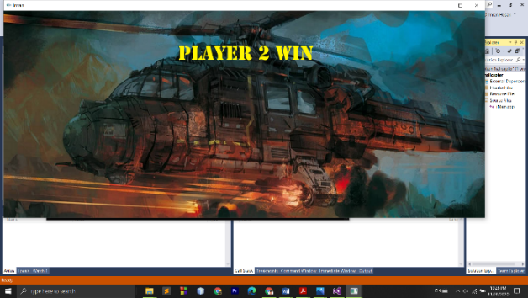

**Figure 4.4-Player Two Win**

After tap Home Button player can go in menu.

# **CHAPTER FIVE**

# **CONCLUSION AND FUTURE SCOPE**

The game was designed and implemented in C++ using SDL, was tested and is working properly. It does have some minor problems with design issues though (difficult to play).

Future for the game:

* Leaderboard
* Stage levels or game levels.
* New obstacles.
* Difficulty level.

Human players added in the future. For computer player, there could be more characters with different artificial intelligence abilities; for human player there could be more characters with different attributes, or advantages and disadvantages.

- Different levels of difficulty could be implemented. With the current level of difficulty set to the highest. The easier levels could have more light spots on the screen for the human player easier to make guesses about the labyrinth.

- Extra objects, such as a diamond, with different properties could be implemented.

- The game could be made into a board game. This could be done by placing square magnets together thus making a labyrinth, then putting the dark carton board above the magnets, and placing the figures – the figure cannot move out of the range of magnets since it will always stick to the path.

But the figure could get into a trap in the labyrinth, because not every path is a solution. It is quite difficult to play because the computer player is too smart and knows the labyrinth. It is winnable of course, but it is a bit difficult – a way to improve it can be to make more computer player characters to choose from, each having unique advantages and disadvantages (rather than having one that is too intelligent). If I had more knowledge in the game programming in previous semesters, then I would make different design decisions, such as either making a computer player’s AI less advanced or giving a human player extra privileges over computer player. I was down to trying to make the game according to the standards of the difficulty of programming in order to pass the course. If I had been thinking about this project as it was a real-life project, which would need to be sold, I would totally reconsider my decision. Only when the game was finished, and I coincidentally was learning about game programming at the same time, I realized how the game could be improved without ridding the project of the programming abilities.